Animal Hearing Ranges

[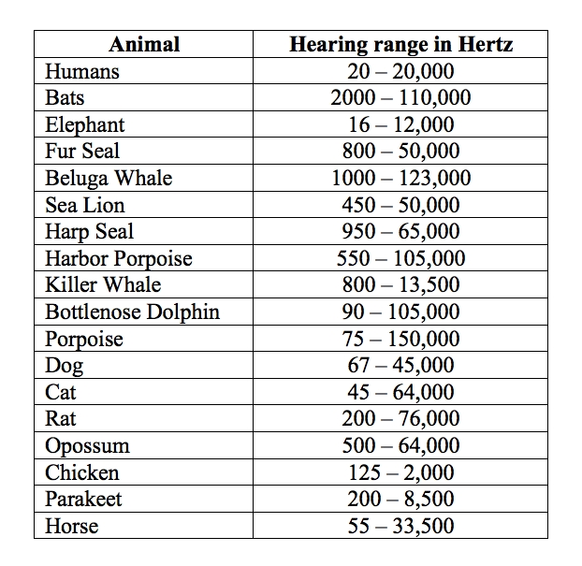](http://www.google.ca/url?sa=i&rct=j&q=&esrc=s&frm=1&source=images&cd=&cad=rja&docid=MX4awHHemC7DTM&tbnid=t-aHJHt_GnpQxM:&ved=0CAUQjRw&url=http%3A%2F%2Fhomepages.ius.edu%2Fkforinas%2FS%2FPitch.html&ei=N9huUquwHuGuiQKt3ICABg&bvm=bv.55617003,d.cGE&psig=AFQjCNEY4iGTgCFmX7gkjS3LZXs4CiLGBw&ust=1383082416622338)

[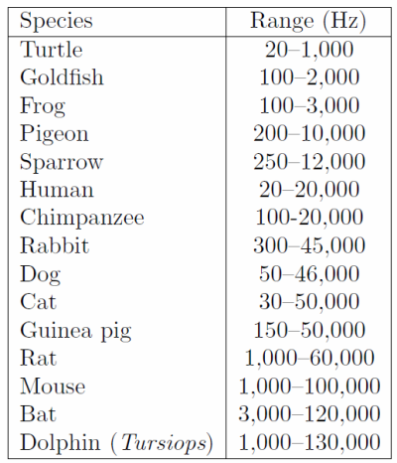](http://www.google.ca/url?sa=i&rct=j&q=&esrc=s&frm=1&source=images&cd=&cad=rja&docid=UKwu_ExWNs8FyM&tbnid=wFno-KQL_nZz3M:&ved=0CAUQjRw&url=http%3A%2F%2Fdonrathjr.com%2Faudible-range-human-hearing%2F&ei=fNhuUtWwMMm8iwKfoICoDA&bvm=bv.55617003,d.cGE&psig=AFQjCNEY4iGTgCFmX7gkjS3LZXs4CiLGBw&ust=1383082416622338)

[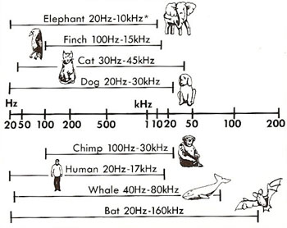](http://www.google.ca/url?sa=i&rct=j&q=&esrc=s&frm=1&source=images&cd=&cad=rja&docid=Pem2NxFe6oRxBM&tbnid=h8h2Ee4DWh9ExM:&ved=0CAUQjRw&url=http%3A%2F%2Fwww.daviddarling.info%2Fchildrens_encyclopedia%2FSpeak_Chimpanzee_Chapter1.html&ei=tNhuUrjMLcSeiQL6qoDQCQ&bvm=bv.55617003,d.cGE&psig=AFQjCNEY4iGTgCFmX7gkjS3LZXs4CiLGBw&ust=1383082416622338)

[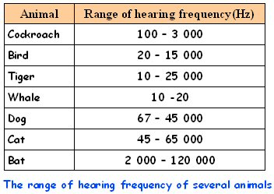](http://www.google.ca/url?sa=i&rct=j&q=&esrc=s&frm=1&source=images&cd=&cad=rja&docid=ykcKPXK9ZCXX4M&tbnid=PPinylSuMy_9sM:&ved=0CAUQjRw&url=http%3A%2F%2Fwww.scorea.com.my%2Feng%2Fexamhall%2Fenotes%2FAF21511.html&ei=z9huUvbTMqubigK2-IDYCg&bvm=bv.55617003,d.cGE&psig=AFQjCNEY4iGTgCFmX7gkjS3LZXs4CiLGBw&ust=1383082416622338)